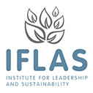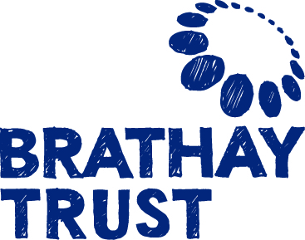

**Leading Wellbeing Research Festival 16-18 July 2015**

**Booking form**

**NAME AND CONTACT DETAILS:**

Name:

Job Title:

E-mail:

Tel Number:

Any special dietary or other needs:

**ATTENDANCE:**

Please book conference places @400.00 p/p (first 30 places will be discounted to £300 early bird price)

Please book conference places with a charity, public body or university concession @ £200.00 p/p

Please book conference places with a Brathay or UoC staff/student/alumni concession @ £100.00 p/p

A limited number of student volunteer places are available; please get in touch for more information.

Brathay Trust will issue any visa invitation letters only on receipt of confirmation of a booked flight and receipt of ticket payment.

Thanks to some very generous sponsorship, a separate children’s activity programme will be available. Please indicate below if you are interested in this and we will contact you.

Please tick here if you would like to bring children / request a children’s programme of activities. Note that adult family members are charged at the same rate as other delegates, if attending the festival.

Please note children’s places are limited.

**Number and age(s) of children:**

Cheque:  Made payable to ‘Brathay Trust’ (only if drawn on UK bank account)

BACS:  Bank transfers should be made to: Barclays, Market Place, Ambleside, Cumbria, LA22 9BY

Sort Code: 20-45-28, Account No: 80202592

Swift Code BARCGB22

IBAN: GB69 BARC 2045 2880 2025 92

Please use the following as a reference when making the transfer :

‘Wellbeing’ ‘Your Surname, Your Postcode’ e.g. ‘Smith, LA22 OHP’

Invoice:  Please specify any reference to be included on the invoice.

**Reservations will only be confirmed upon receipt of the booking fee.**

**Please note no cancellations can be accepted after 1 June 2015. Prior to June 1st a 50% refund can be made.**

**Please tick here if you would like to submit an abstract for presenting a paper at the research festival**

* **then complete and return the abstract submission form by 16 March 2015.**

**Please tick here if you would like accommodation information – this will be sent with your booking confirmation**

**Return to:** Wellbeing Co-ordinator

**Address:** Brathay Trust, Brathay Hall, Ambleside, Cumbria, LA22 0HP

**Telephone:** 015394 39700

**Email:** [wellbeing@brathay.org.uk](mailto:wellbeing@brathay.org.uk)