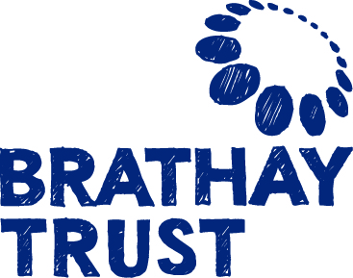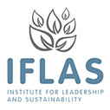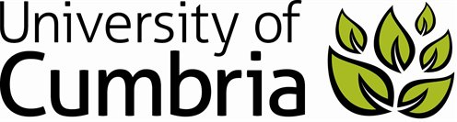

**Leading Wellbeing Research Festival 16 – 18 July 2015**

**Abstract Submission Form**

Brathay Trust and the University of Cumbria welcome abstract submissions on the theme of leading wellbeing.

Sustainable business is contingent on leading sustainable business practices, economies, communities and a sustainable planet. The leadership task is to create sustainability. Equally, leaders must consider how they support wellbeing within and outside their businesses through their business activities. Alleviation of poverty and social justice can only be achieved through the combined efforts of local and global leaders. Wellbeing and sustainability are mutually reinforcing concepts, we cannot sustain anything if we are not ‘well’, nor can wellbeing be achieved in a world where resources are at risk. Leadership, wellbeing and sustainability are therefore overlapping concepts.

Interprofessional working is at the heart of the solutions. Single disciplinary solutions cannot succeed, leaders must work across professional and disciplinary boundaries and collaborate to create powerful and mutually reinforcing solutions to the complex issues of the modern world.

This research festival is situated at the nexus of sustainability, wellbeing and leadership, three concepts that are inextricably linked. We welcome submissions for 15 minute verbal papers that are situated between two or three of these areas and across a range of disciplines.

We welcome submissions from practitioners, academics, and researchers across all disciplines, especially new presenters. We hope for rich sessions that disseminate information and stimulate debate and discussion.

**To submit your abstract please fill in the form below:**

**Your name:**

**Abstract title:**

Summary of the content of your presentation (no more than 200 words):

Benefits to attendees (no more than 100 words):

Presentations will not make use of AV equipment, instead papers and presentations will be delivered verbally ensuring an engaging, high quality conference experience.

**The deadline for abstract submissions is 16 March 2015**

**We will notify you if you are included by mid-April 2015**

**Return to:** Wellbeing Co-ordinator

**Address:** Brathay Trust, Brathay Hall, Ambleside, Cumbria, LA22 0HP

**Telephone:** 015394 39700

**Email:** [wellbeing@brathay.org.uk](mailto:wellbeing@brathay.org.uk)